Lab 13
Sorting Algorithms

Objective:
The objective of this experiment is to implement Quicksort, Heapsort and MergeSort and observe the performance of these algorithms w.r.t. time complexity

Introduction:
Quicksort is a comparison sort, meaning that it can sort items of any type for which a "less-than" relation (formally, a total order) is defined. In efficient implementations it is not a stable sort, meaning that the relative order of equal sort items is not preserved. Quicksort can operate in-place on an array, requiring small additional amounts of memory to perform the sorting.
Mathematical analysis of quicksort shows that, on average, the algorithm takes O(n log n) comparisons to sort n items.
Quicksort is a divide and conquer algorithm. Quicksort first divides a large array into two smaller sub-arrays: the low elements and the high elements. Quicksort can then recursively sort the sub-arrays.
The steps are:
- Pick an element, called a pivot, from the array.
- Partitioning: reorder the array so that all elements with values less than the pivot come before the pivot, while all elements with values greater than the pivot come after it (equal values can go either way). After this partitioning, the pivot is in its final position. This is called the partition operation.
- Recursively apply the above steps to the sub-array of elements with smaller values and separately to the sub-array of elements with greater values.
The base case of the recursion is arrays of size zero or one, which never need to be sorted.
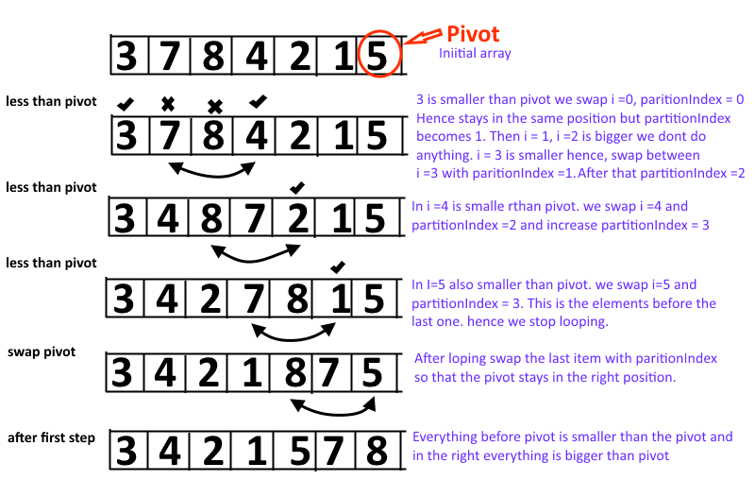

Exercise 1: Implement Quicksort on a series of randomly generated numbers (Note: use rand()%100 for random values). The size of this array is asked by the user at runtime (see the client below)
You may use the following code as given in your textbook, you will need to write the SWAP function yourself. Please note the execution time for arrays of big size (greater than or equal to 1000) and then compare this time with that taken by an elementary sorting algorithm such as bubblesort (code of which is given within the client for your convenience).
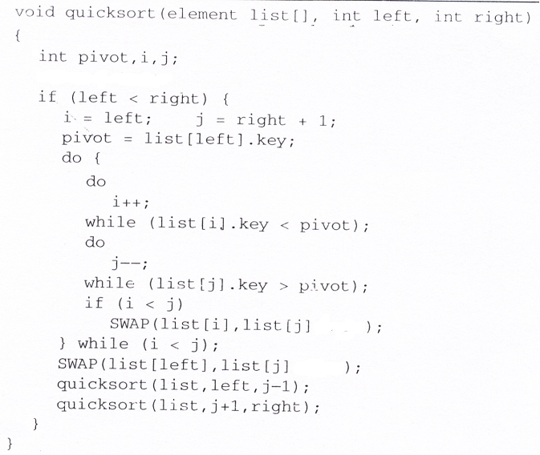

You may test your code using the following client
#include<iostream>
#include<Windows.h>
using namespace std;

void BubbleSort(int list[], int left, int right)
{
for (int i=left; i < right; i++)
for (int j=right ; j > i; j--)
{
if (list[j] < list[j-1])
{
int temp=list[j];
list[j]=list[j-1];
list[j-1]=temp;
}
}
}
int main()
{
int size;
cout<<"Enter array size: ";
cin>>size;

int *arrQ=new int[size];
int *arrB=new int[size];
DWORD start, end;

for (int i=0; i<size; i++)
arrQ[i]=rand()%100;

for (int i=0; i<size; i++)//arrB is going to be a copy of arrQ
arrB[i]=arrQ[i];

if(size<=100)//display array contents on console before Quicksorting
for(int i=0; i<size;i++)
cout<<arrQ[i]<<" ";

cout<<endl;

start= GetTickCount();
quicksort(arrQ, 0, size-1);
end= GetTickCount();

double cpu_time_used = end - start;
cout<<" Time taken by Quicksort = "<<cpu_time_used<<"milliseconds"<<endl;

if(size<=100)//display array contents on console after Quicksorting
{
for(int i=0; i<size;i++)
cout<<arrQ[i]<<" ";
}
cout<<endl<<endl;
if(size<=100)//display array contents on console before Bubblesorting
for(int i=0; i<size;i++)
cout<<arrB[i]<<" ";
cout<<endl;
start= GetTickCount();
BubbleSort(arrB, 0, size-1);
end= GetTickCount();

cpu_time_used = end - start;
cout<<" Time taken by Bubblesort = "<<cpu_time_used<<"milliseconds"<<endl;

if(size<=100)//display array contents on console after Bubblesorting
for(int i=0; i<size;i++)
cout<<arrB[i]<<" ";

cout<<endl;
return 0;
}

Exercise 2: Implement Heapsort on a series of randomly generated numbers (Note: use rand()%100 for random values). The size of this array is asked by the user at runtime (see the client below). Please note that in Heapsort array starts from index 1 and goes upto the index of size. Please change the client given above accordingly.
You may use the following code as given in your textbook. Please note the execution time for arrays of big size (greater than or equal to 1000) and then compare this time with that taken by Quicksort as well as an elementary sorting algorithm such as bubblesort.

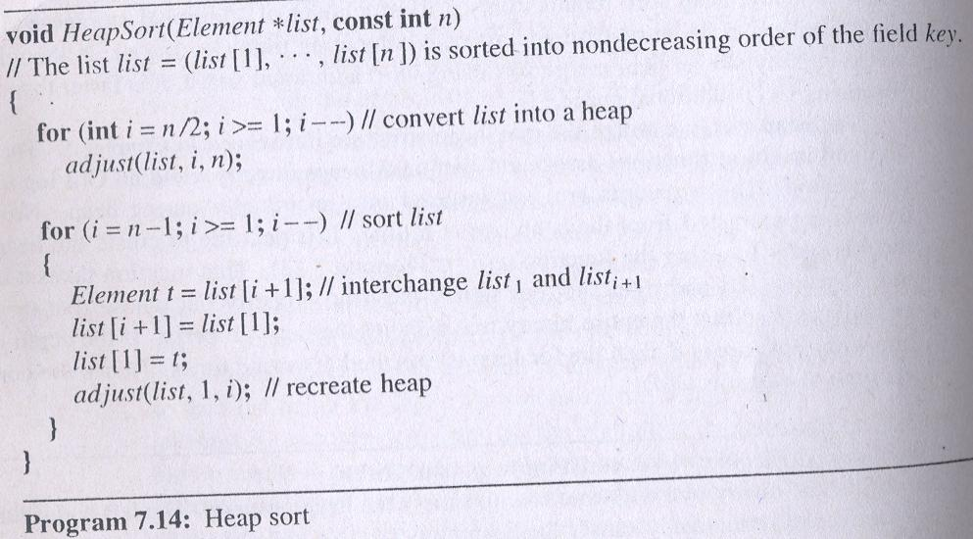

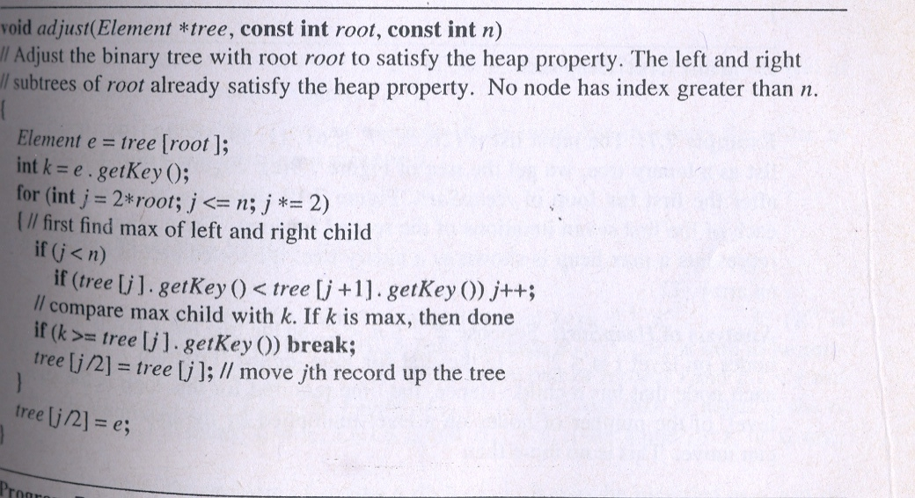

POST LAB:
Implement Mergesort on a series of randomly generated numbers (Note: use rand()%100 for random values). The size of this array is asked by the user at runtime (see the client below).
You may use the code for Mergesort given in your textbook. Please note the execution time for arrays of big size (greater than or equal to 1000) and then compare this time with that taken by Quicksort, Heapsort and an elementary sorting algorithm such as bubblesort.

